**Introduction to Full Stack Development:**

* Full Stack Development refers to the practice of building both the front-end (client-side) and back-end (server-side) components of a web application.
* A Full Stack Developer is proficient in working with both the user interface and the server-side logic, making them capable of handling all aspects of web development.

**Overview of Full Stack Development:**

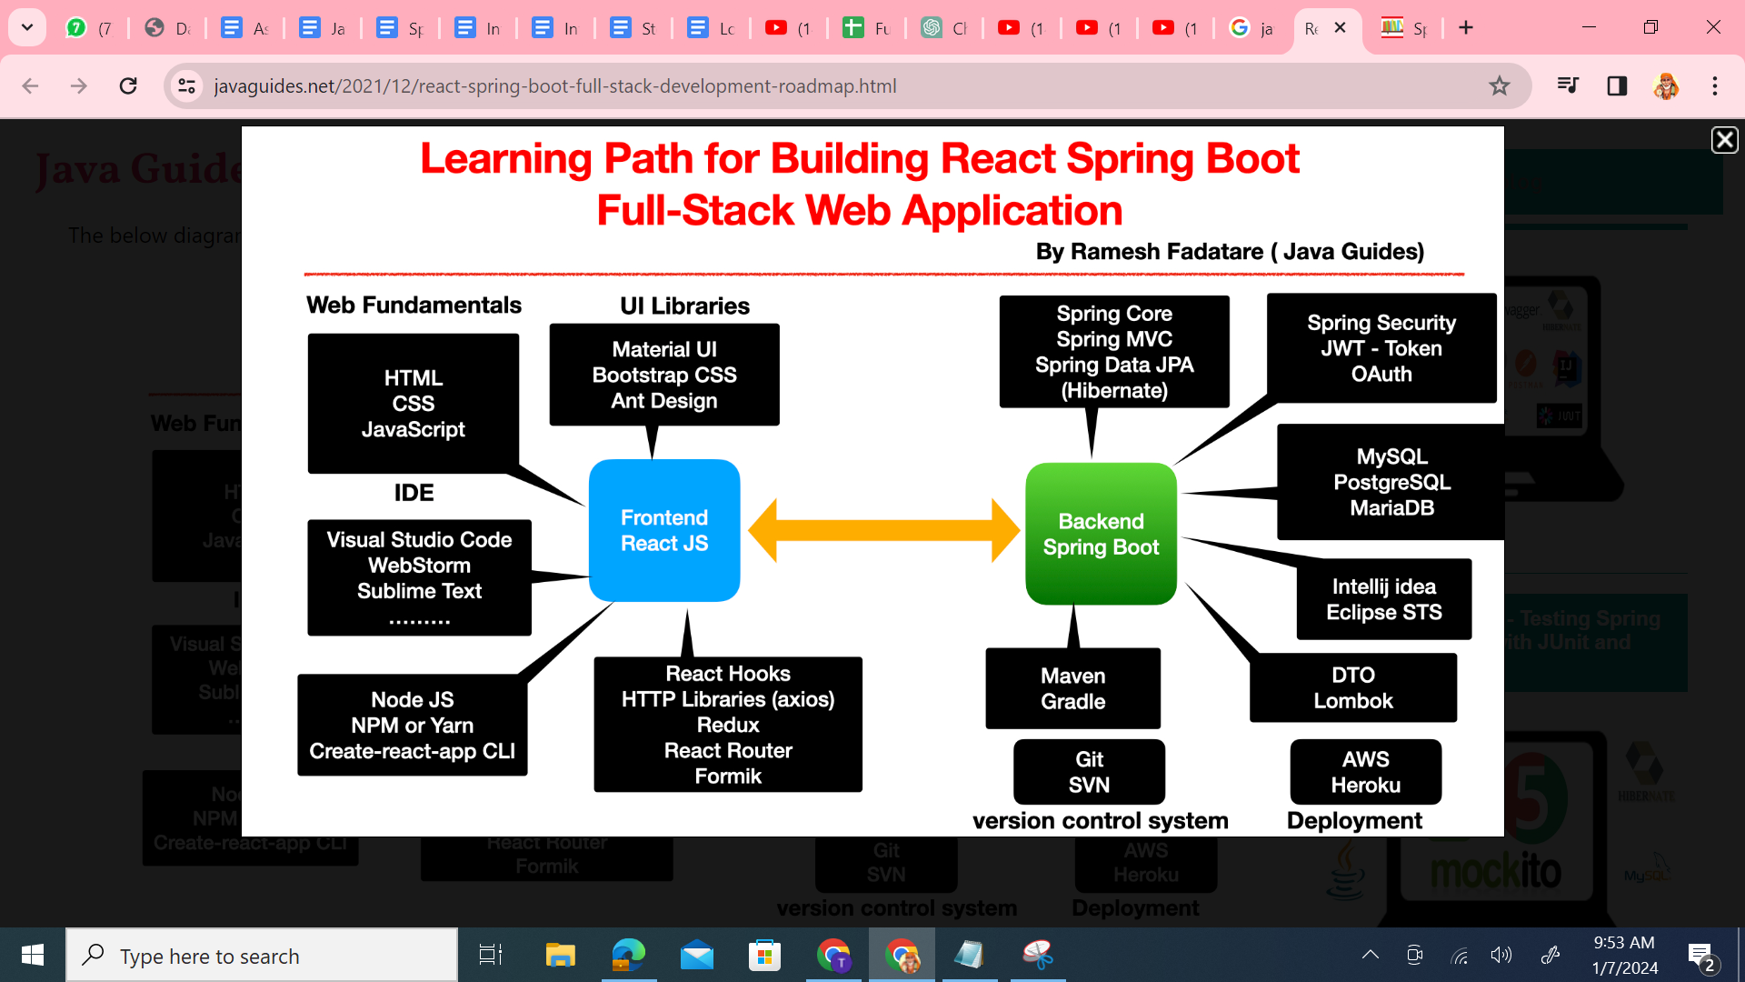

1. Front-end (Client-Side):

- This involves the user interface and user experience (UI/UX).

- Technologies include **HTML, CSS, JavaScript**, and various front-end frameworks like React, **Angular**, or Vue.

2. Back-end (Server-Side):

- This focuses on server-side logic, databases, and server management.

- Technologies include server-side languages like **Node.js**, Python (Django/Flask), Ruby (Ruby on Rails), **Java (Spring)**, or PHP.

3. Database Management:

- Involves storing and retrieving data efficiently.

- Technologies include relational databases (**MySQL**, PostgreSQL) or NoSQL databases (MongoDB, Cassandra).

4. Version Control/**Git**:

- Essential for tracking changes and collaborating on projects.

5. APIs (Application Programming Interfaces):

- Interaction between different software systems.

- **RESTful APIs**, GraphQL.

6. Basic DevOps:

- Knowledge of deployment, server management, and containerization (Docker).

**Importance of Full Stack Development in Modern Applications:**

1. Versatility:

- Full Stack Developers can work on both front-end and back-end, offering versatility and efficiency.

2. Faster Development:

- A single developer can handle the entire project, reducing communication overhead.

3. Cost-Effective:

- Hiring one Full Stack Developer can be more cost-effective than hiring separate front-end and back-end developers.

4. Problem Solving:

- Full Stack Developers have a holistic view, making it easier to troubleshoot and solve problems across the entire application.

Key Technologies in Full Stack Development:

1. Front-end:

- HTML, CSS, JavaScript, React, Angular, Vue.

2. Back-end:

- Node.js, Python (Django/Flask), Ruby (Ruby on Rails), Java (Spring), PHP.

3. Databases:

- MySQL, PostgreSQL, MongoDB.

4. Version Control:

- Git.

5. APIs:

- RESTful APIs, GraphQL.

6. DevOps:

- Docker, continuous integration, and deployment tools.

**Demo Example: Setting up a Basic Development Environment for Full Stack Development**

1. Install a Code Editor:

- Eclipse IDE

2. Version Control Setup:

- Install Git and set up a repository.

3. Front-end Setup:

- Install Node.js for JavaScript runtime or Java(Spring)

- Set up a basic HTML, CSS, and JavaScript file.

4. Back-end Setup:

- Depending on the chosen technology (Node.js, Java(Spring)Python, Ruby, etc.), set up the development environment.

5. Database Setup:

- Install and configure the chosen database (MySQL, PostgreSQL, MongoDB).

6. API Development:

- Create a simple RESTful API using the chosen back-end technology.

7. Integration:

- Connect the front-end and back-end components, ensuring seamless communication.

8. Testing:

- Implement basic tests to ensure the functionality of the application.

9. DevOps:

- Explore basic deployment using Docker or other containerization tools.

This demo example provides hands-on experience in setting up a basic Full Stack Development environment, giving a glimpse into the process of building a complete application.